Assessment-1
CompTia A+
Section A — Concept Application

S 1 SCENARIO You are setting up a new office workstation and need to choose the core hardware for it from a supplier's parts list.
Question: Explain the process of selecting a compatible motherboard, CPU, RAM, and storage device for a new office workstation, and justify how you would confirm they will work together.
Answer
To build a new office workstation, I would select a compatible motherboard, CPU, RAM, and storage device by comparing their specifications and checking the manufacturer's compatibility information. The aim is to build a reliable computer that performs everyday office tasks efficiently.
1. Selecting the motherboard
The motherboard is the main circuit board that connects all computer components and allows them to communicate with each other.
- Check the CPU socket and chipset to ensure they support the selected processor.
- Verify the supported RAM generation, such as DDR4 or DDR5.
- Check the maximum RAM capacity and the number of memory slots.
- Ensure that the motherboard has suitable storage connections, such as SATA ports or an M.2 slot.
- Confirm that the motherboard fits the selected computer case.
Example: If I choose a motherboard that supports DDR5 memory, I must select compatible DDR5 RAM rather than DDR4 RAM.
2. Selecting the CPU (Central Processing Unit)
The CPU is the brain of the computer. It executes instructions and processes data required to run applications.
- Check whether the CPU socket matches the motherboard.
- Confirm that the motherboard chipset and BIOS support the processor.
- Consider the number of cores, processing speed, power consumption, and cooling requirements.
- Select a processor suitable for office applications, web browsing, video conferencing, and multitasking.
Example: An Intel Core i5 processor can be suitable for an office workstation, provided the selected motherboard supports that particular CPU model.
3. Selecting RAM (Random Access Memory)
RAM temporarily stores the data and instructions that the CPU needs while programs are running.
- Choose a RAM generation supported by the motherboard, such as DDR4 or DDR5.
- Check the supported memory speed and maximum capacity.
- Verify that the RAM module fits the motherboard's memory slots.
- Choose sufficient memory for smooth multitasking.
Example: I would consider 16 GB of RAM for a typical office workstation to run applications such as Microsoft Office, web browsers, and video conferencing software smoothly.

4. Selecting the storage device
A storage device permanently stores the operating system, applications, documents, and other files.
- Check whether the motherboard supports SATA SSDs, M.2 SATA SSDs, or M.2 NVMe SSDs.
- If choosing an M.2 SSD, verify the supported interface and physical size.
- Consider storage capacity, speed, reliability, and cost.
- Prefer an SSD over a traditional HDD when fast startup and application loading are priorities.
Example: A 512 GB NVMe SSD would be a reasonable option for an office workstation because it provides storage for the operating system, office applications, and documents, along with fast data access.
5. How would I confirm that all components are compatible?
I would follow these steps before purchasing and assembling the computer:
- Check the motherboard manual: Review the manufacturer's official specifications for supported processors, memory, and storage devices.
- Verify CPU compatibility: Confirm the CPU socket, chipset support, and BIOS requirements.
- Verify RAM compatibility: Ensure the RAM generation, capacity, speed, and physical form factor are supported.
- Verify storage compatibility: Check that the motherboard has the appropriate SATA or M.2 connection and supports the selected SSD's interface.
- Check power and cooling: Ensure that the power supply provides sufficient power and that the CPU cooler is compatible.
- Check physical compatibility: Confirm that the motherboard, cooler, and other components fit inside the computer case.
- Test the assembled workstation: Start the computer and enter the BIOS/UEFI to verify that the CPU, RAM, and storage device are detected. Then install the operating system and test basic functionality.
6. Conclusion
Selecting compatible hardware requires checking the technical specifications of each component rather than choosing parts based only on price or brand. By verifying the CPU socket, chipset, RAM type, storage interface, BIOS support, power requirements, and physical dimensions, I can ensure that the motherboard, CPU, RAM, and storage device work together properly. This process helps create a reliable and efficient workstation for everyday office activities.
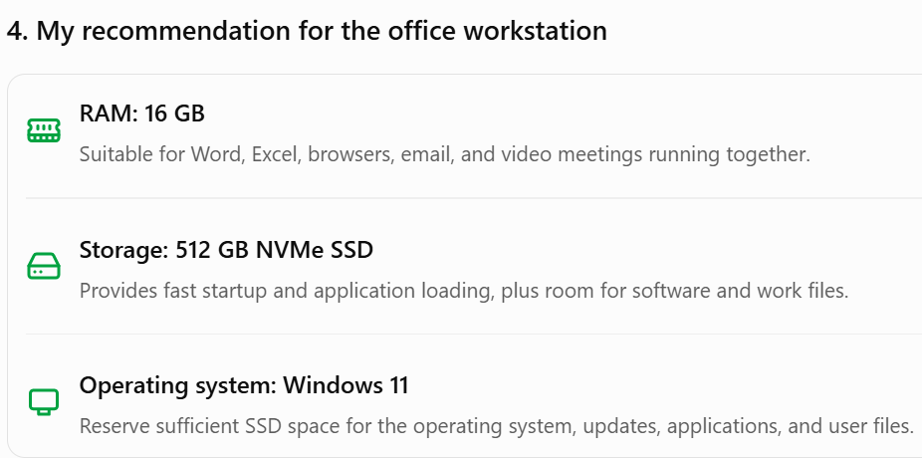

S 2 SCENARIO You are advising a client whose employees mainly run office and productivity applications on their workstations.
Question: Explain the differences between HDD, SSD, and NVMe storage, and recommend the most suitable option for this workload, giving technical reasons for your choice.
Answer
Storage devices are used to store the operating system, applications, documents, and other files. HDD, SSD, and NVMe-based storage differ in their technology, speed, cost, and performance.
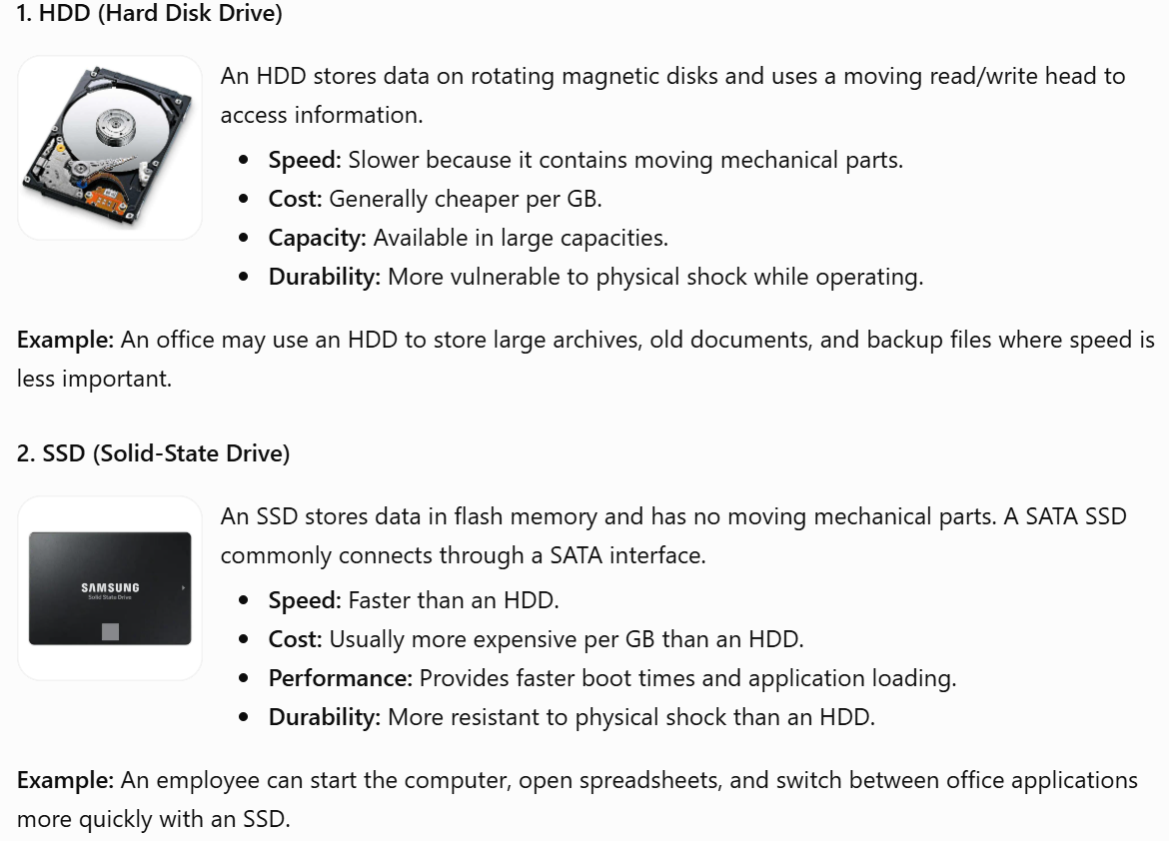

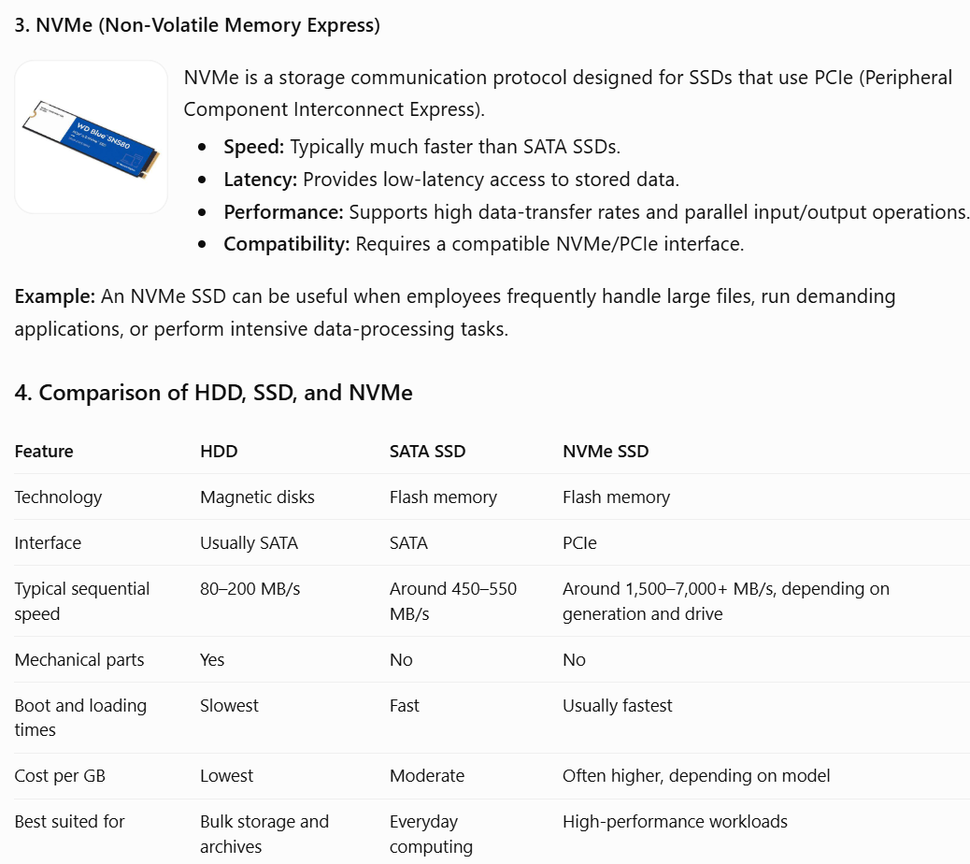
Note: Speeds are approximate examples, not guarantees. Actual performance depends on the device model, interface, workload, and system configuration.

5. Recommendation for office and productivity applications
I recommend an SSD, preferably an NVMe SSD if the workstation supports it and the price difference is reasonable.
The technical reasons are:
- Faster startup: An SSD reduces the time required to load the operating system.
- Quicker application loading: Office software, browsers, and other productivity applications can open faster.
- Better responsiveness: Flash storage avoids the mechanical delays associated with HDDs, making everyday tasks feel smoother.
- Improved multitasking: SSDs handle frequent file access and application loading efficiently when several programs are open.
- Lower noise and power consumption: SSDs have no moving parts and generally operate silently while using less power than comparable HDDs.
A SATA SSD is already sufficient for many basic office workloads. An NVMe SSD is a good choice for new workstations because it offers higher potential transfer speeds and low latency, although employees performing ordinary office tasks may notice only a modest improvement over a good SATA SSD.
6. Conclusion
HDDs are economical for storing large amounts of data, SATA SSDs provide a significant performance improvement for everyday computing, and NVMe SSDs offer higher speeds through the PCIe interface. For employees mainly using office and productivity applications, I would choose an SSD with approximately 512 GB of capacity, preferably NVMe when supported and cost-effective. This provides a good balance of speed, reliability, capacity, and cost.

S 3 SCENARIO You are configuring a workstation that will run mildly graphics-intensive design software for several hours a day.
Question: Explain the role of the GPU and the cooling system in maintaining performance and stability under this kind of sustained load.
1. Introduction
When a workstation runs graphics-intensive design software for several hours a day, components such as the GPU (Graphics Processing Unit) and the cooling system play an important role in maintaining performance, preventing overheating, and ensuring system stability.
Examples of design software include AutoCAD, Blender, Adobe Photoshop, and video-editing applications.
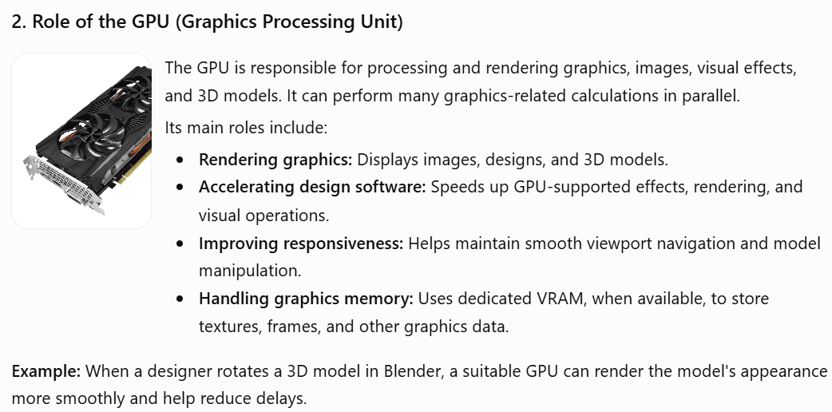

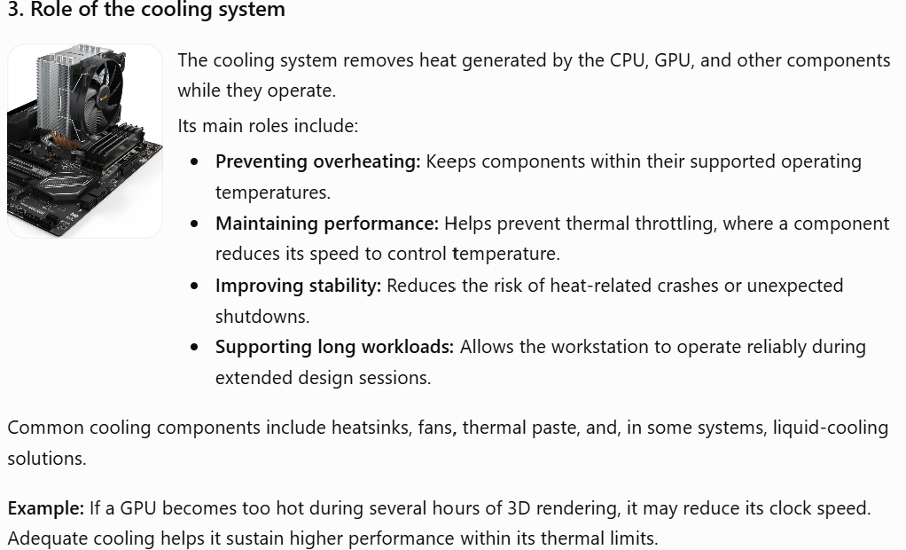
4. How do the GPU and cooling system work together?
The GPU performs graphics calculations, which generate heat. The cooling system transfers that heat away from the GPU and releases it into the surrounding air.
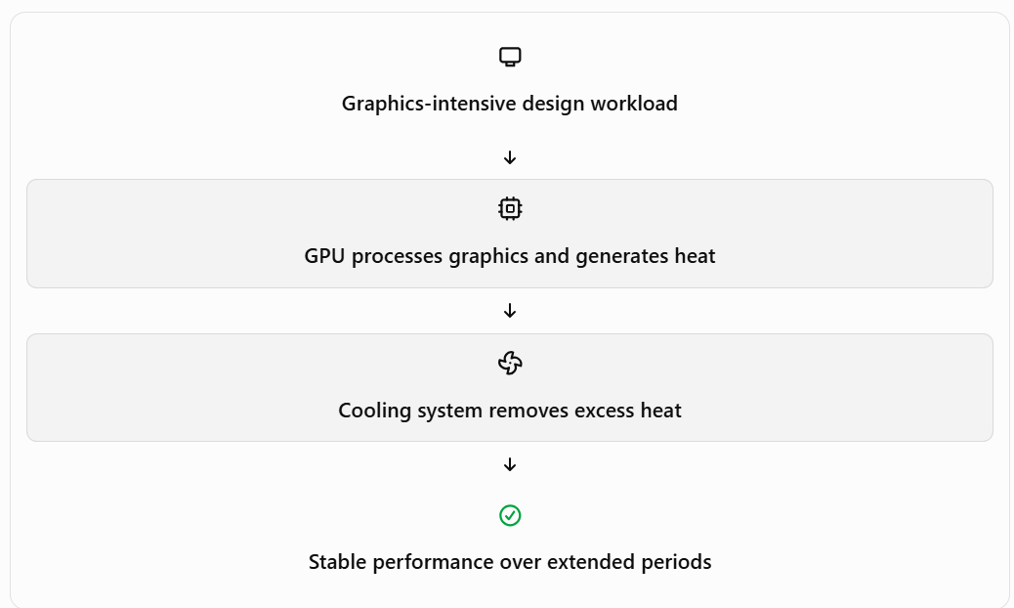
For sustained workloads, both components must be suitable: a powerful GPU without adequate cooling may throttle, while excellent cooling cannot compensate for an underpowered GPU.
5. Recommendations for this workstation
I would recommend the following:
- Choose a suitable GPU: Select a dedicated GPU with sufficient graphics performance and VRAM for the intended design software and project complexity.
- Provide adequate cooling: Use an appropriate GPU cooler, CPU cooler, and case fans to maintain effective airflow.
- Maintain the workstation: Clean dust from fans and heatsinks and ensure that ventilation openings are unobstructed.
- Monitor temperatures: Use hardware monitoring software to check GPU and CPU temperatures during extended workloads.
- Ensure sufficient power: Use a reliable power supply that meets the GPU's power requirements.
6. Conclusion
The GPU accelerates graphics processing and improves the responsiveness of design applications, while the cooling system removes the heat generated during operation. Both are essential for a workstation that runs graphics-intensive software for several hours daily. Selecting an appropriate GPU and maintaining effective cooling helps prevent thermal throttling, reduce overheating risks, and ensure reliable, consistent performance.

S 4 SCENARIO You are assembling a PC from components sourced from three different vendors.
Question: Explain why hardware compatibility matters when assembling a computer, and identify potential issues that could arise from incompatible components.
1. Introduction
Hardware compatibility means ensuring that all computer components are technically suitable to work together. When assembling a PC using components from three different vendors, it is important to check their specifications before purchasing or installing them.
Components such as the motherboard, CPU, RAM, storage device, GPU, power supply, and cooling system must be compatible with one another.
If incompatible components are installed, the computer may fail to start, perform poorly, overheat, or become unstable.
2. Why does hardware compatibility matter?
1. Ensures proper communication between components
The motherboard connects all hardware components and allows them to communicate with each other.
- The CPU must be supported by the motherboard.
- RAM must match the supported memory generation.
- Storage devices must use supported interfaces.
Example: If a motherboard supports DDR4 RAM, installing DDR5 RAM will not work because the memory type and physical slot are different.
2. Prevents system startup failures
Every component must meet the motherboard's technical requirements for the computer to start correctly.
Example: If an incompatible CPU is installed, the computer may fail to complete the POST (Power-On Self-Test) and may not boot.
3. Maintains system performance
Compatible components help the computer operate efficiently without unnecessary performance limitations.
Example: If a workstation uses a high-performance GPU but has an insufficient power supply, the computer may crash or shut down during demanding tasks.
4. Prevents overheating and hardware damage
Components require suitable power and cooling to operate safely.
Example: If the CPU cooler is not compatible with the CPU socket or cannot handle the processor's heat output, the CPU may overheat and reduce its speed through thermal throttling.
5. Reduces additional costs
Checking compatibility before purchasing prevents unnecessary expenses caused by returning or replacing unsuitable components.
Example: Purchasing DDR5 RAM for a DDR4-only motherboard would result in wasted money because the RAM cannot be installed or used.
3. Potential problems caused by incompatible components
Incompatible components | Possible issue
CPU and motherboard | Computer may not start or complete POST.
RAM and motherboard | RAM may not fit or may not be detected.
Storage and motherboard | SSD may not be recognized or may not fit the connector.
GPU and power supply | System may crash or shut down due to insufficient power.
CPU and cooling system | CPU may overheat and experience thermal throttling.
Motherboard and computer case | Motherboard may not physically fit inside the case.
4. How can we prevent hardware compatibility problems?
Before assembling a computer, I would follow these steps:
- Check manufacturer specifications: Read the official product manuals and technical specifications of each component.
- Verify CPU and motherboard compatibility: Check the CPU socket, chipset, and BIOS support.
- Check RAM compatibility: Confirm the RAM generation, supported capacity, and memory speed.
- Verify storage connections: Ensure that the motherboard supports the selected SATA or M.2 NVMe SSD.
- Check GPU compatibility: Verify the physical dimensions, available PCIe slot, and power requirements.
- Check the power supply: Ensure that the PSU provides sufficient wattage and the required power connectors.
- Check physical dimensions: Confirm that the motherboard, GPU, and CPU cooler fit inside the computer case.
- Test the assembled computer: Start the system, check BIOS/UEFI detection, and test the operating system and hardware.
5. Real-world example
Suppose I am assembling an office workstation using components from three different vendors:
- Motherboard from ASUS.
- Processor from Intel.
- RAM from Kingston.
- Storage from Samsung.
- Graphics card from MSI.
Even though these components come from different manufacturers, they can work together if their technical specifications are compatible.
For example, I must ensure that the ASUS motherboard supports the selected Intel processor, the Kingston RAM generation, and the Samsung SSD interface.
Important: Components do not have to come from the same manufacturer. Their technical compatibility matters more than their brand.
6. Conclusion
Hardware compatibility is essential when assembling a computer because it ensures that all components work together correctly, safely, and efficiently. Incompatible components can cause startup failures, hardware detection problems, overheating, poor performance, and unexpected shutdowns. Therefore, checking manufacturer specifications, supported interfaces, power requirements, and physical dimensions before purchasing and assembling components helps build a reliable and stable computer.

S 5 SCENARIO You are finalizing the build and need to connect the power supply unit (PSU) to the motherboard, GPU, and storage devices before first boot.
Question: Explain how you would choose an appropriately rated PSU for this build and describe the safety and connection checks you would carry out before powering it on.
1. Introduction
The Power Supply Unit (PSU) is a hardware component that converts AC power from the wall socket into DC power required by computer components such as the motherboard, CPU, GPU, and storage devices.
Choosing the correct PSU is important because insufficient or unstable power can cause system crashes, unexpected shutdowns, and hardware problems.
2. How would you choose an appropriately rated PSU?
I would consider the following factors:
1. Calculate total power requirements
- Check the power consumption of the CPU, GPU, motherboard, storage devices, and other components.
- Add their estimated power requirements.
- Choose a PSU with additional capacity (headroom) to handle power spikes and future upgrades.
Example: If the computer's estimated power requirement is 400 watts, I would consider a 550–650 watt PSU, depending on the GPU manufacturer's recommendations and the system's requirements.
2. Check PSU efficiency rating
Choose a PSU with an appropriate 80 PLUS efficiency rating, such as Bronze, Gold, or Platinum.
- Higher efficiency means less energy is wasted as heat.
- A good-quality PSU helps provide stable and efficient power.
3. Check required connectors
Ensure that the PSU has the correct connectors:
- 24-pin ATX connector for the motherboard.
- 4-pin or 8-pin EPS connector for CPU power.
- 6-pin or 8-pin PCIe / appropriate GPU power connector.
- SATA power connectors for SSDs and HDDs.
4. Choose a reliable PSU
Select a PSU from a reputable manufacturer with appropriate safety protections, good build quality, and warranty support.
3. Safety and connection checks before powering on
Before switching on the computer, I would perform these checks:
1. Switch off the power: Ensure the PSU is switched off and unplugged from the wall socket before making connections.
2. Connect the motherboard: Attach the 24-pin ATX power connector securely to the motherboard.
3. Connect CPU power: Connect the 4-pin or 8-pin CPU power cable to the motherboard's CPU power socket.
4. Connect GPU power: If the graphics card requires additional power, connect the correct PCIe or 12V-2x6 power cable securely.
5. Connect storage devices: Attach SATA power cables to SATA SSDs and HDDs. M.2 SSDs generally receive power directly through the motherboard slot.
6. Check all connections: Ensure cables are firmly connected, no wires are damaged, and no loose screws or metal objects are inside the case.
7. Check cooling and airflow: Ensure CPU and GPU fans are properly installed and cables are not blocking the fans.
8. Final inspection: Verify that all connections are correct before plugging the PSU into the wall socket and switching it on.
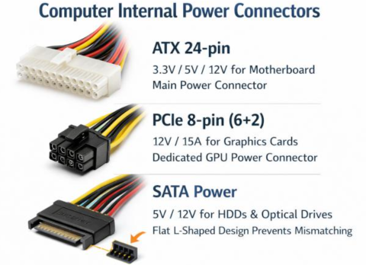
4. What could happen if the wrong PSU is selected?
- Insufficient wattage: The computer may restart or shut down under heavy load.
- Incorrect connectors: Components may not receive the required power.
- Poor-quality PSU: Unstable power delivery may cause system instability or hardware damage.
- Overheating: An overloaded or poorly ventilated PSU may become excessively hot.
5. Conclusion
Selecting the correct PSU requires calculating the total power consumption, allowing sufficient power headroom, checking efficiency, and verifying connector compatibility. Before the first boot, all power connections, cables, cooling arrangements, and safety conditions must be checked. These steps help ensure safe operation and reliable performance of the computer.

S 6 SCENARIO You are handing over a freshly assembled workstation to the client and need to confirm it is ready for use.
Question: Explain the checks you would perform to confirm the system passes POST successfully, and what you would do if it did not.
1. Introduction
POST (Power-On Self-Test) is a diagnostic process performed by the computer's BIOS/UEFI when the computer is switched on.
It checks whether essential hardware components, such as the CPU, RAM, motherboard, and graphics hardware, are functioning properly before the operating system starts loading.
2. Checks to confirm the system passes POST
I would perform the following checks:
1. Check power supply:
- Switch on the computer and check whether the power supply and motherboard receive power.
- Confirm that fans start spinning and power indicators turn on.
2. Check display output:
- Ensure that the monitor is connected properly.
- Confirm that the manufacturer's logo or BIOS/UEFI screen appears.
3. Check BIOS/UEFI:
- Enter BIOS/UEFI using the appropriate key, such as DEL or F2.
- Verify that the CPU, RAM, and storage devices are detected correctly.
4. Check POST indicators:
- Observe motherboard diagnostic LEDs or listen for beep codes, if supported.
- A successful POST generally allows the system to continue to the boot process without a hardware error.
5. Check boot process:
- Confirm that the computer proceeds to the operating system boot screen.
- Ensure that no hardware error messages appear.

3. What would I do if the system failed POST?
If the computer does not pass POST, I would troubleshoot systematically.
Problem | Possible solution
No power | Check the power cable, PSU switch, and power connections.
No display | Check monitor cables, GPU installation, and display connections.
RAM error | Reseat RAM and test one memory stick at a time.
CPU error | Check CPU installation, CPU power connector, and motherboard compatibility.
Beep codes or diagnostic LEDs | Refer to the motherboard manual to identify the faulty component.
Storage not detected | Check SATA cables or M.2 SSD installation.
Important safety precaution: Before removing or reseating any internal component, switch off the PSU, unplug the power cable, and take precautions against electrostatic discharge (ESD).
4. Real-world example
Suppose I switch on a newly assembled workstation, but the monitor displays a black screen and the motherboard's DRAM diagnostic LED remains illuminated.
I would:
- Switch off and unplug the computer.
- Remove and carefully reseat the RAM.
- Try starting the computer with one RAM stick in the motherboard-recommended slot.
- If it still fails, test another compatible RAM stick.
- Check the motherboard manual for further diagnostic guidance.
If the problem is resolved, I would enter BIOS/UEFI and verify the installed memory.
5. Conclusion
POST is important because it checks whether essential hardware components are working correctly before the operating system loads. I would verify power, display output, BIOS/UEFI detection, and diagnostic indicators. If POST fails, I would identify the error, inspect the relevant component, and perform systematic troubleshooting. This ensures that the workstation is stable and ready for the client to use.
B Section B — Practical Coding Tasks
Task 1: Component Identification & Functions
Identify and describe the function of the motherboard, CPU, RAM, GPU, storage device, and cooling system.
Note the make/model or key specification of each component where visible.
Present the findings as a labeled component list or table.
1. Introduction
A desktop computer consists of several hardware components that work together to process data, store information, run applications, and display output.
During this practical activity, I identified the motherboard, CPU, RAM, GPU, storage device, and cooling system from the available desktop PC.
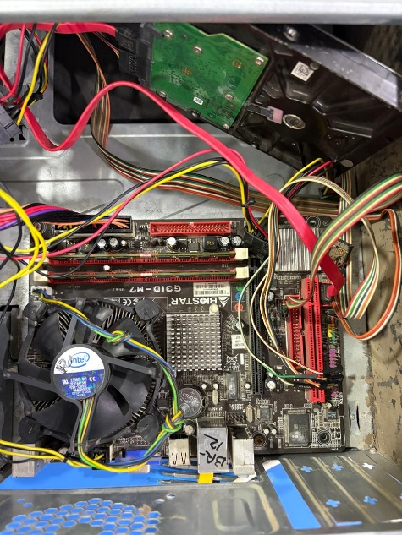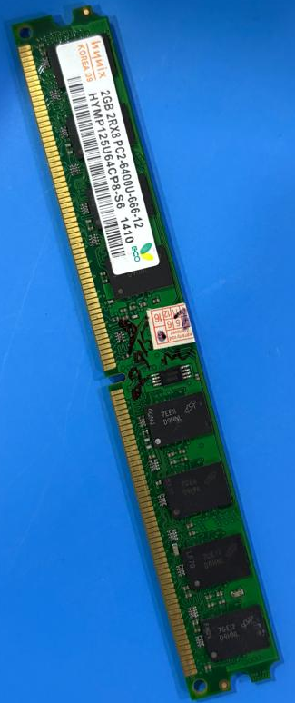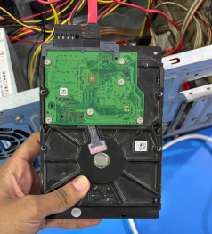
2. Identification and functions of hardware components
1. Motherboard
- Manufacturer: BIOSTAR
- Model: G31D-M7
- Function: The motherboard is the main circuit board of a computer. It connects all hardware components, including the CPU, RAM, GPU, and storage devices, and allows them to communicate with each other.
- Observation: The motherboard has two visible RAM slots, processor socket, expansion slots, and storage connectors.
2. CPU (Central Processing Unit)
- Manufacturer: Intel (indicated by the Intel cooling fan).
- Model: Exact processor model not visible.
- Function: The CPU is the brain of the computer. It executes instructions, performs calculations, and processes data required to run applications.
- Observation: The processor is installed beneath the Intel heatsink and cooling fan.
3. RAM (Random Access Memory)
- Manufacturer: The visible module label indicates WIMAX.
- Capacity: 2 GB.
- Type: DDR2.
- Speed: PC2-6400 (DDR2-800).
- Function: RAM temporarily stores data and instructions that the CPU needs while applications are running. It helps the computer perform tasks and multitask.
- Observation: The separate RAM module has a visible label showing 2 GB DDR2 PC2-6400.
4. GPU (Graphics Processing Unit)
- Function: The GPU processes images, videos, graphics, and visual output displayed on the monitor.
- Observation: The computer may use integrated graphics, but its exact model needs to be verified.
5. Storage Device (HDD)
- Type: 3.5-inch Hard Disk Drive (HDD).
- Function: The storage device permanently stores the operating system, software, documents, photos, and other files, even when the computer is switched off.
- Observation: The photograph shows a traditional HDD with SATA power and data connections.

6. Cooling System
- Manufacturer: Intel (visible fan branding).
- Type: Intel stock CPU cooling fan with heatsink.
- Function: The cooling system removes heat generated by the CPU and prevents overheating. It helps maintain stable performance during operation.
- Observation: A cooling fan is installed above the processor with a heatsink underneath it.
3. Practical observation table
Component | Make / Model / Specification
Motherboard | BIOSTAR G31D-M7
CPU | Intel – exact model not visible
RAM | WIMAX, 2 GB DDR2-800
GPU | Integrated graphics likely; model unconfirmed
Storage | 3.5-inch SATA HDD; capacity unknown
Cooling system | Intel stock fan and heatsink
4. Conclusion

In this practical activity, I identified six important hardware components of a desktop computer and understood their functions. The motherboard connects all components, the CPU processes instructions, RAM temporarily stores active data, the GPU handles graphics, the HDD stores data permanently, and the cooling system controls temperature. Identifying these components helps understand how a desktop computer operates.

Task 2: Motherboard Ports & Socket Identification Identify the motherboard's physical layout, ports, and CPU socket type. (Applied — one concept examined in detail across multiple points.) Identify and label all major motherboard ports (SATA, power, USB headers, etc.).
Identify all expansion slots (PCIe, M.2, etc.) and their purpose.
Identify the CPU socket type and note which CPU families are compatible with it. Photograph or diagram the motherboard with labels.
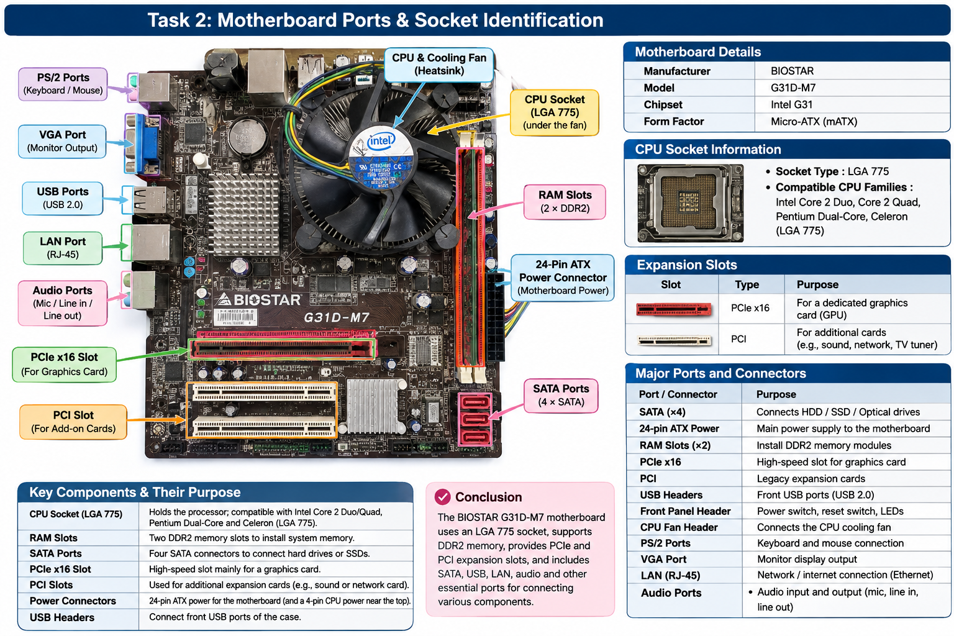

Task 3: RAM & Storage Installation Remove and reinstall a RAM module and a storage device. (Intermediate — two components handled together with correct procedure.)
Safely remove the RAM module, noting ESD precautions taken.
Reinstall the RAM module correctly and confirm it is seated properly.
Remove and reinstall the storage device, noting the connection type used (SATA/NVMe). Confirm both components are detected correctly after reinstallation.

1. Introduction
RAM and storage devices are important hardware components of a desktop computer. RAM temporarily stores data required by the CPU, whereas a storage device permanently stores the operating system, applications, and user files.
In this practical activity, I performed the removal and reinstallation procedure for a RAM module and a hard disk drive (HDD), following appropriate safety precautions.
2. RAM Removal and Reinstallation
Component identification:
- RAM capacity: 2 GB
- RAM type: DDR2
- Speed: PC2-6400 (DDR2-800)
- Motherboard: BIOSTAR G31D-M7
A. Steps to safely remove the RAM
- Shut down the computer completely.
- Switch off the power supply and disconnect the power cable.
- Press the power button briefly to discharge residual power.
- Wear an anti-static wrist strap or touch an unpainted metal part of the computer case to reduce static electricity.
- Locate the RAM module on the motherboard.
- Release the locking clips at both ends of the RAM slot.
- Carefully hold the RAM module by its edges and pull it straight out without touching its gold contacts.
B. Steps to reinstall the RAM
- Check the RAM module and motherboard slot for dust or physical damage.
- Align the notch on the RAM module with the matching key in the motherboard slot.
- Insert the RAM module evenly into the slot.
- Apply gentle, even pressure until the module is fully seated.
- Confirm that the locking clips secure the RAM module properly.
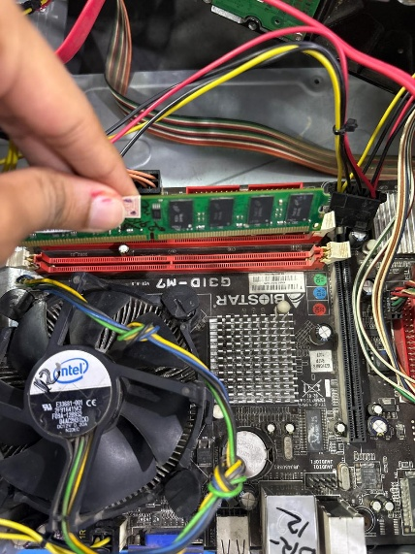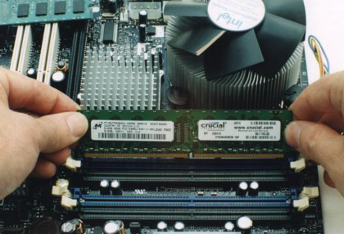
3. Storage Device Removal and Reinstallation
Component identification:
- Device: 3.5-inch HDD
- Connection type: SATA
- Capacity: Not visible in the photograph.
A. Steps to remove the HDD
- Switch off and unplug the computer.
- Locate the HDD inside the computer cabinet.
- Disconnect the SATA data cable from the motherboard and HDD.
- Disconnect the SATA power cable from the HDD.
- Remove the mounting screws carefully.
- Slide the HDD out of its mounting bay while holding it securely.

B. Steps to reinstall the HDD
- Place the HDD correctly inside the drive bay.
- Secure it using the mounting screws.
- Connect the SATA data cable between the HDD and motherboard.
- Connect the SATA power cable from the PSU to the HDD.
- Check that both connections are firmly attached.
- Ensure that the cables do not obstruct the cooling fans.
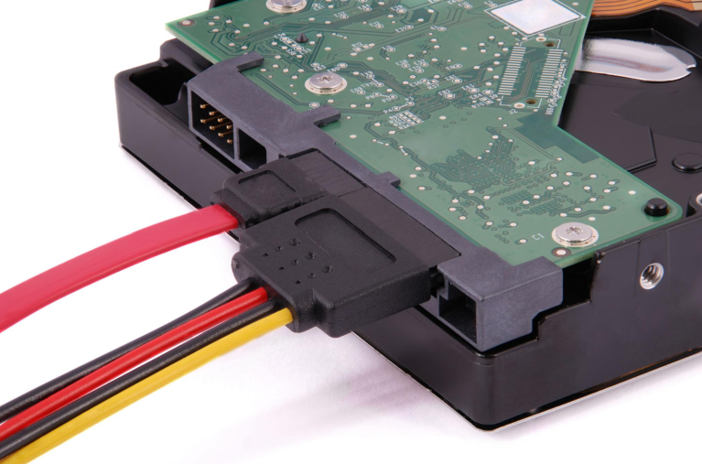
4. Verification After Reinstallation
After reinstalling both components, I would perform the following checks:
RAM verification:
- Start the computer and enter BIOS/UEFI.
- Check whether the installed RAM is detected.
- Verify that the displayed memory capacity matches the installed module.
- Alternatively, check the installed memory in Windows Task Manager under Performance → Memory.
Storage verification:
- Enter BIOS/UEFI and check whether the HDD is detected.
- Open Windows Disk Management to verify that the storage device is recognized.
- Check its capacity and partition information.
5. Safety Precautions
- Always switch off and unplug the computer before removing hardware.
- Use an anti-static wrist strap or appropriate ESD precautions.
- Hold RAM and storage devices by their edges.
- Never force a RAM module into its slot.
- Avoid touching gold contacts and exposed electronic circuits.
- Handle HDDs carefully because they contain sensitive mechanical components.
6. Practical Observation Table
Component | Specification | Connection
RAM | 2 GB DDR2-800 | DDR2 DIMM slot
Storage | 3.5-inch HDD | SATA data and power
7. Conclusion
In this practical activity, I learned how to safely remove and reinstall RAM and a storage device. I followed ESD precautions, checked the alignment of the RAM module, secured it in the motherboard slot, and reconnected the HDD using SATA data and power cables. Finally, I would verify both components through BIOS/UEFI and the operating system to ensure they are detected correctly.
Task 4: Full Desktop PC Assembly Assemble a desktop PC from the provided components and document the process. (Integrative — combines all Section B skills into one build.)
Assemble the PC using the provided motherboard, CPU, RAM, storage, GPU, and PSU.
Follow correct installation sequence and ESD/safety precautions throughout.
Document each step with labeled photos or diagrams.
Power on the system and confirm it passes POST successfully
1. Introduction
Desktop PC assembly involves installing and connecting different hardware components to build a fully functional computer. Each component must be installed correctly and connected to the motherboard and power supply.
In this practical activity, I followed the hardware installation procedure to assemble a desktop PC using the motherboard, CPU, RAM, storage device, GPU, and PSU.
2. Required Hardware Components
Component | Purpose
Motherboard | Connects all hardware components.
CPU | Processes instructions and data.
RAM | Temporarily stores active data.
HDD/SSD | Permanently stores files and operating system.
GPU | Processes graphics and visual output.
PSU | Supplies electrical power to components.
Cooling system | Removes heat and prevents overheating.
Computer case | Holds and protects internal components.
3. Step-by-Step Desktop PC Assembly
Step 1: Prepare the workstation and motherboard
- Place the computer case on a clean, flat surface.
- Switch off and unplug the power supply.
- Use an anti-static wrist strap or touch an unpainted metal part of the case.
- Check the motherboard and other components for physical damage.
- Install the motherboard standoffs in the correct positions inside the case.
Step 2: Install the CPU
- Locate the CPU socket on the motherboard.
- Open the socket retention mechanism.
- Align the CPU's marking with the corresponding socket marking.
- Carefully place the processor into the socket without applying force.
- Lock the retention mechanism.
- Apply thermal paste if required by the cooler's installation instructions.
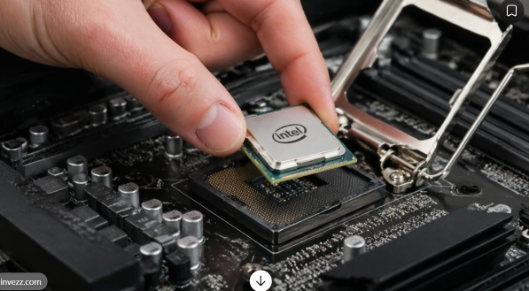
Step 3: Install the CPU cooling system
- Position the CPU cooler over the processor.
- Secure the cooler using its mounting mechanism.
- Connect the CPU fan cable to the motherboard's CPU_FAN header.
- Check that the fan is properly secured and can rotate freely.
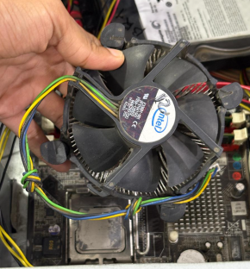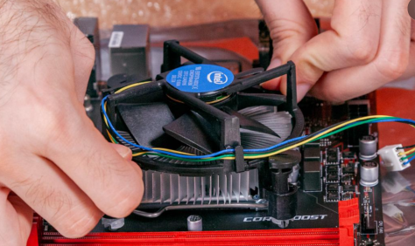
Step 4: Install RAM
- Locate the RAM slots on the motherboard.
- Open the slot locking clips.
- Align the RAM notch with the slot.
- Press the RAM module evenly until the locking clips secure it.
- Check that the module is completely seated.
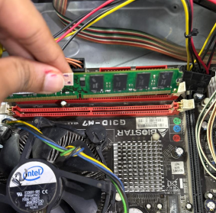
Step 5: Install the motherboard inside the case
- Carefully place the motherboard inside the computer case.
- Align it with the mounting holes and rear I/O panel.
- Secure the motherboard using the appropriate screws.
- Ensure that no extra standoffs are touching the motherboard incorrectly.
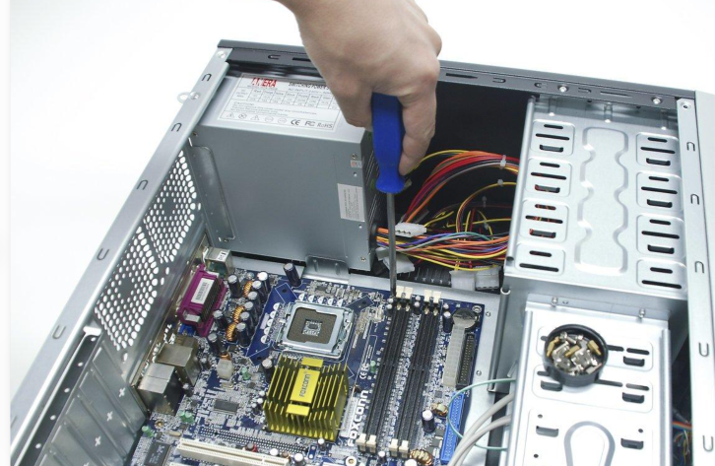
Step 6: Install the storage device
- Place the HDD or SSD in its designated mounting bay.
- Secure it using screws.
- Connect the SATA data cable from the storage device to the motherboard.
- Connect the SATA power cable from the PSU to the storage device.
- If using an M.2 SSD, install it directly into the compatible motherboard M.2 slot instead.
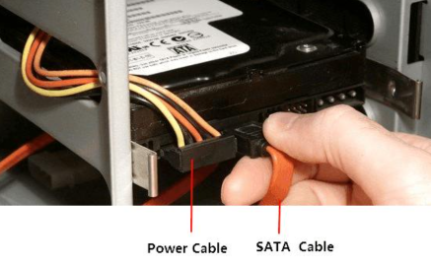
Step 7: Install the GPU
- Locate the appropriate PCIe x16 expansion slot.
- Remove the required rear expansion-slot cover.
- Align the graphics card with the slot.
- Press it gently until the slot locking mechanism engages.
- Secure the graphics card to the case.
- Connect additional GPU power cables if required.
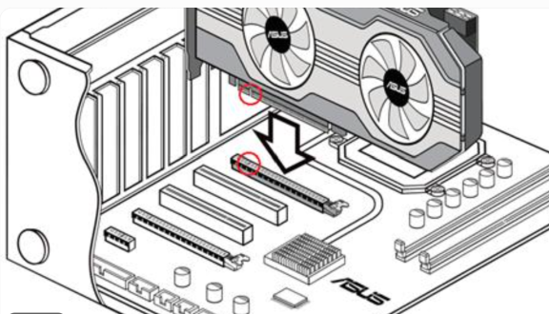
Step 8: Install and connect the PSU
- Place the PSU in its designated position inside the case.
- Secure it using screws.
- Connect the 24-pin ATX power cable to the motherboard.
- Connect the 4-pin or 8-pin CPU power cable.
- Connect the required GPU power cables.
- Connect SATA power cables to HDDs or SATA SSDs.
- Organize the cables to maintain proper airflow.
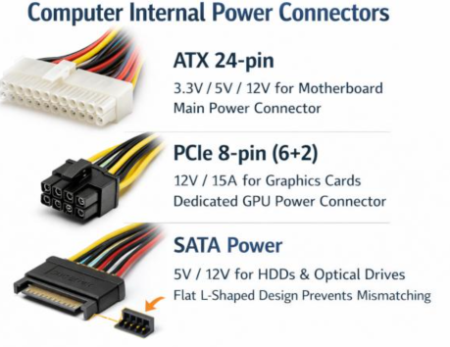
Step 9: Final inspection
Before switching on the computer:
- Check that all components are properly installed.
- Verify that the motherboard and CPU power connectors are secure.
- Ensure RAM and GPU are seated correctly.
- Check SATA data and power connections.
- Confirm that CPU and case fans are connected.
- Remove any loose screws or unnecessary objects from inside the case.
- Ensure that no cables are blocking the cooling fans.

4. Power On and POST Verification
POST (Power-On Self-Test) is a diagnostic process performed by the BIOS/UEFI when the computer starts. It checks essential hardware components before the operating system loads.
I would perform these checks:
- Connect the monitor, keyboard, and mouse.
- Connect the computer to the power supply.
- Switch on the PSU and press the computer's power button.
- Check whether the fans start spinning and the display turns on.
- Enter BIOS/UEFI using DEL or F2.
- Verify that the CPU, RAM, and storage device are detected correctly.
- Confirm that no POST error messages or diagnostic warnings appear.
- Check that the computer proceeds to the operating system boot screen.
If POST fails: Check power connections, RAM seating, CPU installation, GPU connections, and motherboard diagnostic LEDs. Troubleshoot the identified component before attempting another boot.
5. Safety Precautions
- Always disconnect the power supply before installing or removing components.
- Use ESD protection to prevent static electricity damage.
- Handle components by their edges.
- Never force components into slots or connectors.
- Use the correct screws and mounting points.
- Ensure adequate ventilation and proper cable management.
- Never open the PSU casing because it can contain dangerous electrical components.

6. Practical Observation Table
Assembly stage | Verification
CPU installation | Processor correctly seated
Cooling installation | Cooler secured and CPU fan connected
RAM installation | RAM properly seated
Motherboard installation | Board securely mounted
Storage installation | SATA/M.2 connection checked
GPU installation | Card seated in PCIe slot
PSU installation | Power connectors secured
First boot | POST completed successfully
7. Conclusion
In this practical activity, I learned the correct sequence for assembling a desktop computer using its essential hardware components. I followed ESD and electrical safety precautions while installing the CPU, RAM, cooling system, storage device, GPU, motherboard, and PSU. Finally, I powered on the system and used BIOS/UEFI to verify hardware detection and successful POST, confirming that the workstation was ready for operating system installation and further testing.
C Section C — Mini Capstone Project
Mini Project: Workstation Deployment & Boot-Failure Diagnosis Objective: ABC Solutions is setting up a new computer lab. After assembling several systems, some computers fail to start while others display hardware detection errors, and the IT team suspects incorrect installation or compatibility issues. Build (or inspect) a workstation, diagnose the likely causes of these failures, and produce a diagnostic and installation-verification report — combining component selection, installation procedure, and compatibility troubleshooting from Section B.
Your project must:
Identify the three hardware components you would check first when a newly assembled PC fails to boot, and explain why.
Explain how motherboard–CPU compatibility affects system functionality, referencing the specific system you assembled or inspected.
Describe how you would verify that RAM and storage devices are installed correctly, including what BIOS/POST should confirm.
Produce a hardware-installation checklist of at least three steps to prevent similar failures in future deployments. Provide a technical justification for using SSDs instead of HDDs in modern office workstations, tying it back to the lab's use case. D Section D — AI-Augme
1. Introduction
ABC Solutions is setting up a new computer lab with multiple desktop workstations. During installation, some computers fail to start, while others display hardware detection errors.
The main objective of this project is to identify hardware problems, verify component compatibility, diagnose boot failures, and ensure that all workstations operate correctly.
For this practical investigation, I refer to the inspected BIOSTAR G31D-M7 desktop system.
2. Three hardware components to check first when a PC fails to boot
When a newly assembled computer fails to start, I would initially inspect the following three components.
1. Power Supply Unit (PSU)
Function: The PSU converts AC electricity into DC power required by the motherboard, CPU, GPU, and storage devices.
Possible problems:
- Loose motherboard power connectors.
- Insufficient PSU wattage.
- Faulty power supply.
- Damaged power cables.
How to diagnose:
- Check whether the PSU switch is ON.
- Verify the 24-pin motherboard power connector.
- Check the 4-pin or 8-pin CPU power connector.
- Check whether fans and motherboard power indicators turn on.
Example: If the 24-pin power connector is loose, the motherboard may not receive the required power, preventing the computer from starting.
2. RAM (Random Access Memory)
Function: RAM temporarily stores data and instructions required by the CPU while the computer is running.
Possible problems:
- RAM not properly seated.
- Incompatible RAM generation.
- Faulty RAM module.
- Dirty or damaged memory contacts.
How to diagnose:
- Switch off and unplug the computer.
- Remove and reinstall the RAM module.
- Check whether it is properly locked into the slot.
- Test one RAM module at a time, using a supported slot.
Example: If RAM is not installed properly, the computer may fail POST and display a DRAM diagnostic light or beep code.
3. CPU (Central Processing Unit)
Function: The CPU processes instructions and performs calculations required to operate the computer.
Possible problems:
- Incompatible CPU and motherboard.
- Incorrect CPU installation.
- Bent or damaged socket pins.
- Missing CPU power connection.
- BIOS not supporting the installed processor.
How to diagnose:
- Verify CPU and motherboard compatibility.
- Check the CPU power connector.
- Inspect the socket and processor installation if necessary.
- Check motherboard diagnostic LEDs and BIOS error messages.
Example: If an unsupported processor is installed, the motherboard may fail to initialize the CPU, resulting in a POST failure.
3. How motherboard–CPU compatibility affects system functionality
The motherboard and CPU must be compatible because the motherboard provides the physical socket, electrical connections, chipset support, and firmware required for the processor to operate.
For compatibility, I would check:
- CPU socket: The processor must fit the motherboard socket.
- Chipset support: The motherboard chipset must support the selected processor.
- BIOS compatibility: The installed BIOS version must recognize the processor.
- Power requirements: The motherboard must provide the required power to the CPU.
Example from the inspected system:
Component | Identified specification
Motherboard | BIOSTAR G31D-M7
Chipset | Intel G31
CPU socket | LGA 775
RAM support | DDR2
Processor | Intel – exact model not identified
The BIOSTAR G31D-M7 uses an LGA 775 socket. It supports compatible Intel processor families such as Core 2 Duo, Core 2 Quad, Pentium, and Celeron, subject to the motherboard's specific CPU support list and BIOS version.
If I install an incompatible processor, the motherboard may not recognize it, and the computer may fail to complete POST.
4. How to verify RAM and storage installation
After assembling the workstation, I would verify both components through BIOS/UEFI and the operating system.
A. RAM verification
Installation checks:
- Ensure the RAM generation is supported by the motherboard.
- Align the notch correctly with the memory slot.
- Press the module evenly until the locking clips secure it.
- Check that the module is completely seated.
BIOS/POST verification:
- Enter BIOS/UEFI using DEL or F2.
- Check whether the installed RAM is detected.
- Verify the displayed memory capacity.
- Check for memory-related POST errors.
Example: If a 2 GB DDR2 RAM module is installed, BIOS should identify approximately 2 GB of installed memory, allowing for minor differences in reported usable memory.
B. Storage device verification
Installation checks:
- Secure the HDD or SSD in its mounting position.
- Connect the SATA data cable to the motherboard.
- Connect the SATA power cable from the PSU.
- Ensure both connections are firmly attached.
BIOS/POST verification:
- Enter BIOS/UEFI.
- Check whether the HDD or SSD appears in the storage device list.
- Verify the detected device model where available.
- Check whether the correct boot device is selected.
Example: If a SATA HDD is connected correctly, BIOS should recognize the drive. If it is not detected, I would inspect the SATA data cable, power connection, and motherboard SATA port.
Expected verification results
Component | Expected result
RAM | Correct memory capacity detected
HDD/SSD | Storage device detected
CPU | Processor identified correctly
POST | No unresolved hardware errors
Boot | System proceeds to the operating system
5. Hardware installation checklist
To prevent similar failures in future deployments at ABC Solutions, I would follow this checklist for every workstation.
No. | Installation and safety check | Purpose
1 | Check CPU socket, chipset, and BIOS compatibility. | Prevent processor compatibility problems.
2 | Verify RAM type, capacity, and seating. | Prevent memory detection failures.
3 | Check motherboard and CPU power connectors. | Ensure proper power delivery.
4 | Connect SATA data and power cables correctly. | Ensure storage detection.
5 | Check GPU installation and power requirements. | Prevent graphics-related startup problems.
6 | Verify CPU cooler and fan connections. | Prevent overheating.
7 | Perform BIOS/UEFI and POST checks. | Confirm hardware detection before deployment.
Important: All internal installation and inspection should be performed with the computer switched off, unplugged, and protected against electrostatic discharge (ESD).
6. Why use SSD instead of HDD in modern office workstations?
An SSD (Solid-State Drive) is generally a better choice than an HDD (Hard Disk Drive) for modern office workstations because it provides faster data access and has no moving mechanical parts.
HDD
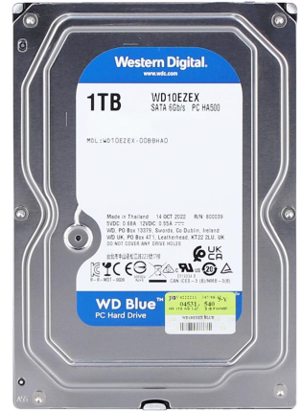
Uses rotating magnetic disks and moving read/write head
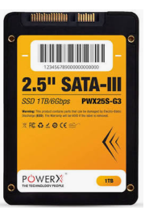
SSD
Uses flash memory with no moving mechanical parts.
Technical comparison
Feature | HDD | SSD
Speed | Slower | Faster
Boot time | Longer | Shorter
Application loading | Slower | Faster
Moving parts | Yes | No
Noise | Produces mechanical noise | Silent
Shock resistance | Lower | Generally higher
Why SSD is suitable for ABC Solutions
- Faster booting: Computers start Windows more quickly.
- Faster application loading: Employees can open Word, Excel, browsers, and other applications faster.
- Better responsiveness: Improves everyday multitasking and file access.
- Lower noise: SSDs operate silently.
- Better physical durability: SSDs are less vulnerable to physical shock because they have no moving parts.
Recommendation: I would recommend a 512 GB SSD with 16 GB RAM for a typical new office workstation, depending on application and storage requirements. An NVMe SSD is preferable where the motherboard supports it; otherwise, a SATA SSD is a suitable option.
For the older BIOSTAR G31D-M7 system inspected, a compatible SATA SSD could be used if supported by the board and configured appropriately.
7. Final Diagnostic Report
Inspection area | Expected outcome
PSU | Stable power delivery
CPU | Compatible and correctly installed
RAM | Properly seated and detected
Storage | HDD/SSD recognized by BIOS
Motherboard | No unresolved hardware errors
Cooling | CPU fan operating correctly
POST | Successfully completed
Operating system | Boots successfully
8. Conclusion
Through this mini project, I understood how to identify and diagnose common hardware-related boot failures in desktop computers. The PSU, RAM, and CPU are three important components to inspect first when a newly assembled system fails to start. I also learned the importance of motherboard–CPU compatibility, correct RAM and storage installation, and BIOS/POST verification.
For ABC Solutions, I recommend following a standard hardware installation checklist and using SSD-based storage in new office workstations. These practices will help reduce installation errors, improve system performance, and provide reliable computers for employees.
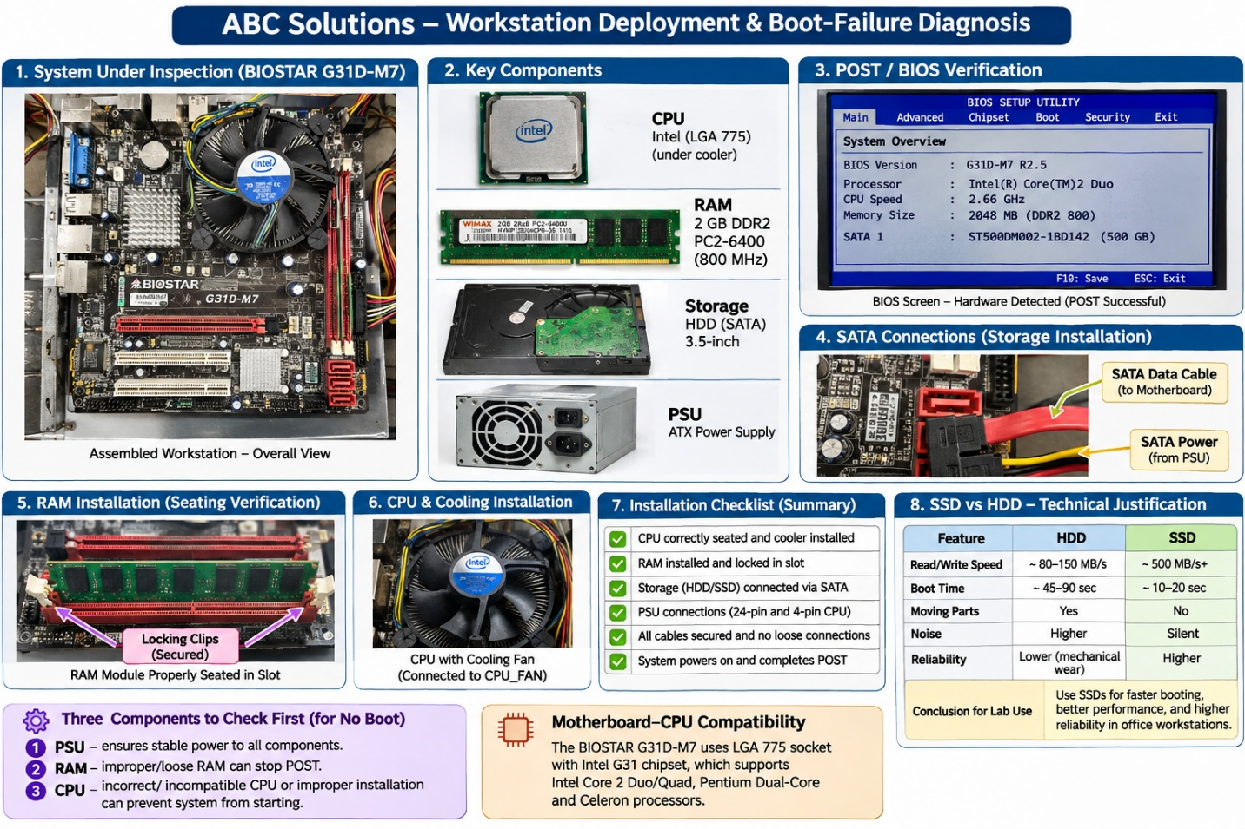

D Section D — AI-Augmented Learning
STEP 1 · BUILD WITH AI
Use an AI tool of your choice (ChatGPT, Claude, Copilot, etc.) to help you produce a step-by-step
troubleshooting checklist that:
Guides a junior technician through diagnosing a desktop PC that fails to boot immediately
after assembly, in the correct priority order.
Covers at minimum the motherboard, RAM, storage, and PSU as possible failure points.
Is presented as a clear checklist or simple decision flow a technician could follow on-site.
Is applied to the ABC Solutions scenario from Section C to show which step would have caught
the reported issue.
STEP 2 · TEST & DEBUG (WITHOUT AI)
Then, working without AI, review the checklist and find at least one step that is missing,
incorrectly ordered, or unsafe (for example, skipping ESD precautions or checking software
before physical connections). Fix it yourself
SUBMIT All 3 items required
1 The exact prompt(s) you gave the AI tool.
2 The AI's original checklist and your corrected version.
3 A 3–4 line note explaining what you changed and why the AI's version needed it.
Act as a desktop hardware troubleshooting expert. Create a step-by-step troubleshooting checklist for a junior technician diagnosing a desktop PC that fails to boot immediately after assembly.

Requirements:
- Arrange troubleshooting steps in the correct priority order, starting with basic power and physical connection checks.
- Cover motherboard, RAM, storage devices, and PSU as possible failure points.
- Include safety precautions such as switching off power and ESD protection.
- Explain how to identify problems using BIOS/UEFI, POST indicators, and diagnostic LEDs.
- Present the solution as a simple checklist that a junior technician can follow.
- Apply the checklist to the ABC Solutions computer lab scenario and explain which step could identify the reported hardware installation or compatibility problem.
Keep the explanation practical, clear, and suitable for a hardware troubleshooting assignment.

2. AI-generated original troubleshooting checklist
This is the initial checklist generated with AI assistance.
Original checklist
Step | Troubleshooting action | Possible issue
1 | Check whether the computer powers on and fans rotate. | Power failure
2 | Check the motherboard power connectors. | Loose 24-pin or CPU power cable
3 | Check whether RAM is properly installed. | Loose or incompatible RAM
4 | Check CPU and motherboard compatibility. | Unsupported processor
5 | Check whether the storage device is detected in BIOS. | Loose SATA cable or faulty HDD/SSD
6 | Check motherboard diagnostic LEDs and beep codes. | Hardware initialization failure
7 | Enter BIOS/UEFI and verify detected hardware. | Incorrect hardware configuration
8 | Attempt to boot into the operating system. | Boot configuration or OS problem
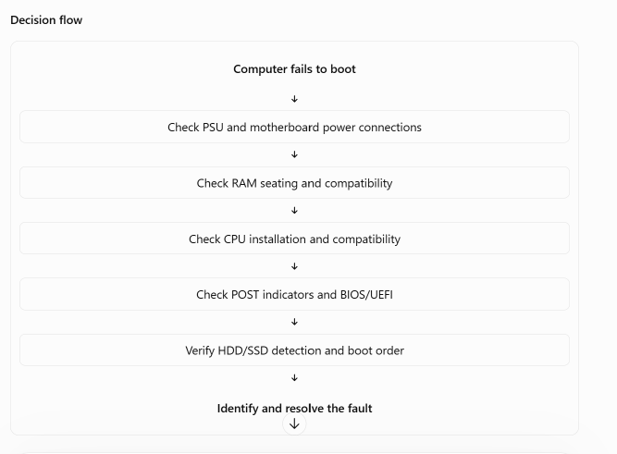
3. My corrected troubleshooting checklist (after reviewing the AI output)
After reviewing the original checklist, I identified that safety precautions should be performed before touching internal hardware. I also improved the order by separating power failure, POST failure, and operating system boot failure.
Corrected checklist
Step | Action to perform | What to check
1 | Switch off and unplug the computer. Apply ESD precautions. | Technician and component safety
2 | Inspect the PSU and power connections. | Power cable, PSU switch, 24-pin ATX and CPU power
3 | Check motherboard installation. | Loose connections, incorrect standoffs and visible damage
4 | Check RAM installation. | Correct DDR generation, seating and locking clips
5 | Check CPU installation and compatibility. | CPU socket, chipset and BIOS support
6 | Switch on and observe POST indicators. | Beep codes, diagnostic LEDs and display output
7 | Enter BIOS/UEFI if POST succeeds. | CPU, RAM and storage detection
8 | Check HDD/SSD connections. | SATA data cable, SATA power and drive detection
9 | Check boot order and operating system. | Correct boot device and OS loading
Important troubleshooting rule: If the computer does not complete POST, troubleshoot hardware first. Storage boot settings and operating system checks come after successful hardware initialization.
How to apply the corrected checklist to ABC Solutions
Consider a workstation in the ABC Solutions computer lab that powers on but displays a black screen and a DRAM diagnostic LED.
I would follow these steps:
- Switch off and unplug the computer and apply ESD precautions.
- Inspect the motherboard and power connections.
- Check whether the RAM module is compatible with the motherboard.
- Remove and reinstall the RAM module correctly.
- Restart the computer and check the POST indicators.
- Enter BIOS/UEFI and confirm that the RAM capacity is detected.
Expected result: If the issue was incorrectly seated RAM, reseating the module should allow the computer to complete POST, provided the module is compatible and functioning correctly.
For the inspected BIOSTAR G31D-M7 system, I would also verify DDR2 compatibility before reinstalling the 2 GB PC2-6400 RAM module.
4. Three-to-four-line note explaining my corrections
After reviewing the AI-generated checklist, I noticed that it did not clearly prioritize ESD protection and power isolation before handling internal components. I corrected the sequence by placing safety precautions and physical connection checks at the beginning. I also separated POST troubleshooting from operating system troubleshooting because hardware detection must be successful before investigating software boot problems. These changes make the checklist safer, more practical, and easier for a junior technician to follow.

